Course Code: |  | : | AI244AI | Date | : | 23-06-2024
Semester |  | : | IV | Time | :
Max Marks |  | : | 10 | Duration | : | 20 mins
Artificial Intelligence and Machine Learning
Quiz II
Note: Answer all the Questions
SL. No | Questions |  |  |  |  |  | M | BT | CO
1 | One of the parameters used to find the algorithm performance is completeness. When do we say the algorithm is complete? |  |  |  |  |  | 1 | L3 | CO1
2 | Mention any one technique to deal with an infinite path problem in DFS. |  |  |  |  |  | 1 | L3 | CO1
3 | Which is memory efficient, DFS or BFS? |  |  |  |  |  | 1 | L2 | CO1
4 | Differentiate informed and uninformed search techniques. |  |  |  |  |  | 1 | L3 | CO1
5 | What are the performance factors that influence the KNN algorithm? |  |  |  |  |  | 1 | L1 | CO5
6 | Distinguish between Euclidean distance and Manhattan distance measures in the KNN algorithm. (Formulas, Plot) |  |  |  |  |  | 1 | L2 | CO1
7 | A diagnostic test has a probability of 0.95 of giving a positive result when applied to a person suffering from a certain disease and a probability of 0.10 of giving a false positive when applied to a non-sufferer. It is estimated that 0.5% of the population are sufferers. Suppose that a test is administered to a person about whom we have no relevant information relating to the disease (apart from the fact that he/she comes from this population). Calculate the following probabilities.  - That the test result is positive.  - That, given a positive result, makes the person a sufferer. |  |  |  |  |  | 2 | L3 | CO5
8 | For the problem given in 7, compute the following  - That given a negative result, the person is a non-sufferer.  - That the person will be misclassified. |  |  |  |  |  | 2 | L3 | CO5

M-Marks, BT-Blooms Taxonomy Levels, CO-Course Outcomes
Marks Distribution | Particulars | CO1 | CO2 | CO3 | CO4 | CO5 | L1 | L2 | L3 | L4 | L5 | L6
 | Max Marks CIE

Course Outcomes: After completing the course, the students will be able to:-
CO1 | Explain and apply AI & ML algorithms to address various requirements of real-world problems.
CO2 | Design and develop AI and ML solutions to benefit society, science, and industry.
CO3 | Use modern tools to create AI and ML solutions.
CO4 | Demonstrate effective communication through team presentations and reports to analyze the impact of AI and ML solutions on society and nature.
CO5 | Conduct Performance evaluation, modeling, and validation of AI and ML solutions benefitting lifelong learning.

Scheme and Solutions
Q. No | Solutions | M
1. | When the algorithm is guaranteed to produce a solution, it is called a complete | 1
2. | Marking the visited node to avoid loops or putting a limit on the depth | 1
3. | DFS | 1
4. | An informed search has some prior information to achieve the direction toward the goal state, whereas an uninformed search is a blind search without any additional information.
5. | - The distance function or distance metric used to determine the nearest neighbours.  - The decision rule used to derive a classification from the K-nearest neighbours.  - The number of neighbours used to classify the new example | 01
6. | 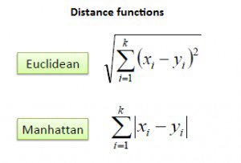  Manhattan: Euclidean:  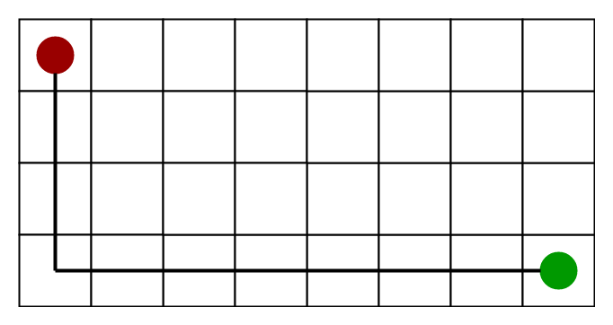  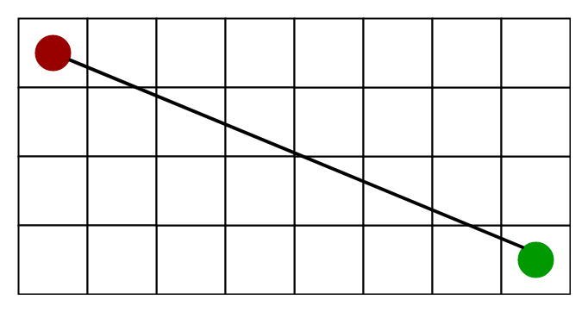 | 01
7 and 8 | 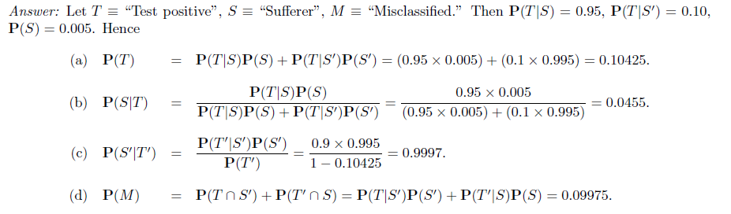 | 04

